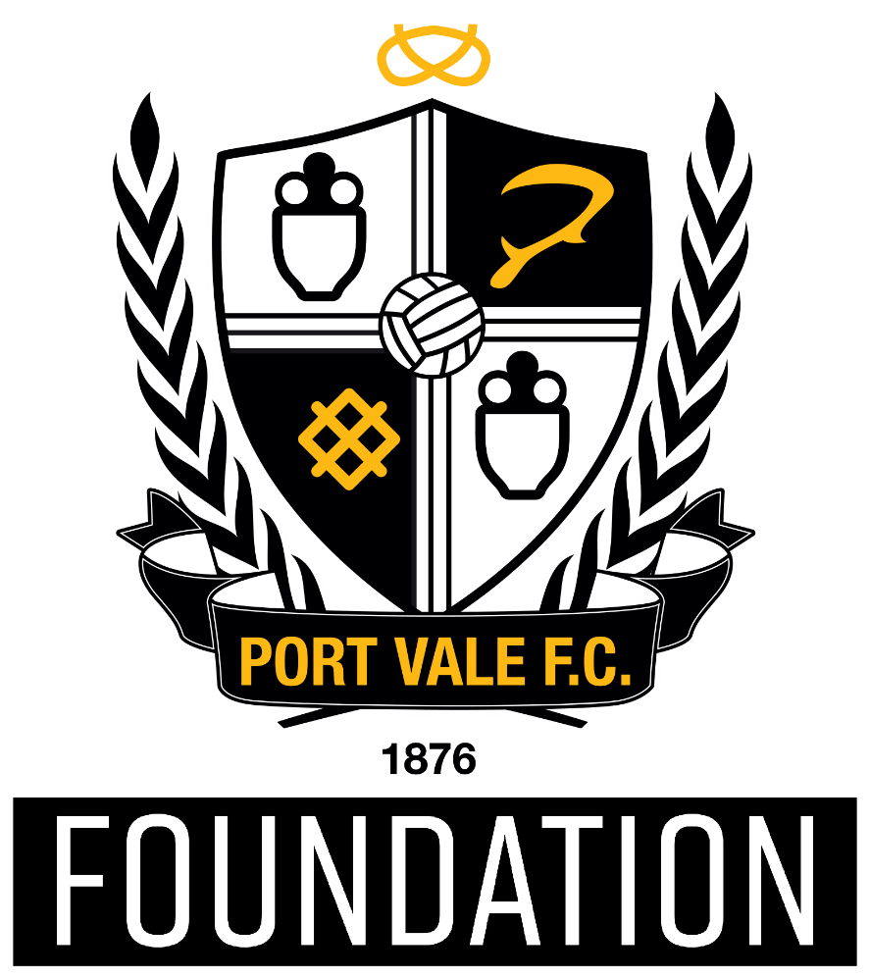

HEAD OF FOUNDATION

**Port Vale Foundation use the power of Port Vale Football Club** to create opportunities to engage, motivate and inspire people to improve their lives and their communities.

We are a values led organisation and strive to live and breathe them each and every day. Our values are:

* **Passionate** – We are passionate about supporting the people of Stoke on Trent and Staffordshire to improve their lives and their communities
* **Collaborative** – We foster and develop innovative partnership with wide ranging organisations to maximise our impact and outcomes
* **Integrity** – We use a robust evidence base and proven practice to inform decisions, measure impact and sustain our activity
* **Inclusive** – We create opportunities for everyone from every background to take part in our programmes and have positive experiences, which lead them to fulfil their potential
* **Excellence** – We provide high quality experiences and support for participants, partners, professionals and staff
* **Proud** – We celebrate success and are visible to everyone, meaning we are valued by our club, our partners and our community.

In order to fulfil our mission, we are actively looking to contribute to local, regional and national priorities, using the Port Vale Football Club Foundation brand to positively impact on a range of agendas such as increasing sport and physical activity, improving health, increasing education standards and improving community cohesion.

To focus and influence the Port Vale FC Foundation in achieving our mission whilst supporting and tackling local priorities, our work is categorised under four core areas:

* Sport & Physical Activity
* Health & Well-being
* Education & Employability
* Community Engagement
* Family Engagement

Under each of our areas, we also identify several priorities for Port Vale FC Foundation that are aligned to various local, regional and national plans and strategies – ensuring that our work contributes to the wider strategic context for Sport, Health, Education and Inclusion.

|  |
| --- |
| **Role Profile – Head of Foundation** |
| **Role Reports to: Director of Community and CSR** |
| **Hours: Full Time Pay scale:**  £40,000 + benefits scheme |
| **The Role: Head of Foundation** |
| Port Vale Football Club has a mission to be a successful club on and off the pitch that sits at the heart of it’s community. We are at an exciting time as we are setting out on a journey, planning our new strategy to be released in 2025. To support the on going growth and development of the community work, we are re-aligning our community operation.  We’re looking for a genuinely good person—someone who treats others with respect, works well in a team, and always strives for excellence. We are a low-ego organisation and we want someone who brings positive energy and values collaboration. You should have the experience and skills to excel in this role, but just as importantly, you should have the right attitude: kind, professional, and committed to making a real difference for the community. If you’re driven, personable, and care deeply about doing great work with great people, you’re exactly who we need. |
| **Main Responsibilities and Accountabilities** |
| **Operational Leadership**   * **Support the Director of Community**: Assist in shaping and delivering the strategic vision for the Foundation and ensuring alignment with the objectives of Port Vale Football Club, supporting the development of the new strategic plan * **Develop Operational Plans**: Create and implement operational plans that support strategic goals, ensuring targets are met and exceeded across community initiatives. * **Drive Programme Growth**: Innovate and expand programmes to meet community needs, with a particular focus on areas such as health, education, families, community engagement. * **Finance**: Efficiently manage budgets, staffing, and resources to maximise impact and sustainability across all Foundation activities.   **People Management**   * **Lead and Motivate the Team**: Oversee, support, and develop the Foundation team to ensure high performance, engagement, and a culture of high performance. * **Performance Management**: Set clear objectives, conduct regular performance reviews, and provide feedback to all team members, identifying development needs and areas of growth   **Quality Assurance**   * **Maintain High Standards**: Oversee the quality assurance framework to ensure all programmes are delivered to the highest standard and achieve positive, measurable outcomes. * **Compliance and Safeguarding**: Ensure all activities adhere to EFL and club safeguarding policies, health and safety regulations, and other relevant guidelines such as Capability Code of Practice, promoting best practices across all programmes. * **Evaluation and Reporting**: Oversee the monitoring and evaluation processes for all initiatives, supporting the collection of data and providing feedback to funders, stakeholders, and the community.   **Programme Development and Community Engagement**   * **Identify Community Needs**: Conduct regular needs assessments to ensure programs are relevant, impactful, and responsive to the local community. * **Programme Development and Creativity:** Support the department leads to innovate, check, challenge and create meaningful programmes for our service users. * **Partnership Development**: Cultivate relationships with local authorities, schools, businesses, charities, and other stakeholders to enhance program delivery, leverage resources, and increase the Foundation's impact. |
| This role demands relevant experience and a deep understanding of the community, sports, or charity sectors. You’ll need proven expertise in managing teams, delivering impactful programmes, and ensuring compliance with safeguarding and quality standards. A level of financial acumen, project management skills, and the ability to communicate effectively with diverse stakeholders are essential. While qualifications such as a degree in Community Development, Sports Management, or a related field are desirable, what truly matters is your ability to leverage your knowledge and experience to create meaningful, lasting impact. |

If you would like to apply for this role please send across your CV and a covering letter to [HR@port-vale.co.uk](mailto:HR@port-vale.co.uk) or you can send it by post to:

**Job Vacancies**

**Port Vale**

**Vale Park**

**Hamil Road, Burslem**

**Stoke-on-Trent, ST6 1AW**

If you require any more information, please call us on 01782 757066.