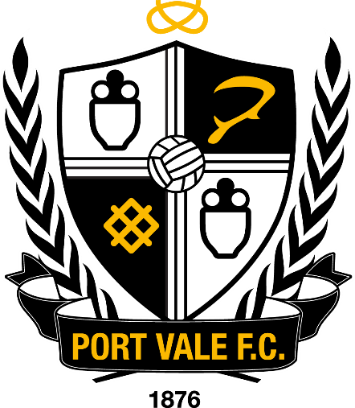





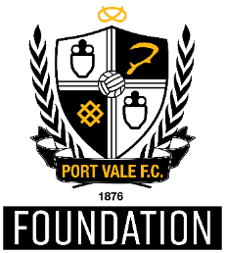

FURRY MASCOT “BOOMER”
POLICY & PROCEDURES
2025-26
For the latest copy refer to the Club Website

Version Control
Document Title: | Furry Mascot Policy 2022/2023
Document Owner: | Port Vale Football Club – Gary Cliffe – Head of Safeguarding
Reference: | February 2023 (Revised Version)

Document Review
Last Reviewed | Position
03/2021 | Revised Policy – Jon Bloore
08/2021 | Revised Policy – Tim Bailey
08/2022 | Revised Policy – Tim Bailey
02/2023 | Revised Policy – Rich Talbot
31/07/2025 | Annual Review – Gary Cliffe

Version History
Version | Date Released | Originator | Authorised | Comments
1.0 | 09/2018 | Unknown | Board | Revised Version
1.1 | 03/2021 | Jon Bloore | Board | Revised Version
1.2 | 08/2021 | Tim Bailey | Board | Revised Version
1.3 | 08/2022 | Tim Bailey | Board | Revised Version
1.4 | 02/2023 | Rich Talbot | Board | Revised Version
1.5 | 03/08/2023 | Rich Talbot | Board | Revised Version
1.6 | 31/07/2025 | G Cliffe | Board | Revised Version

1. Introduction
Port Vale Football Club (hereafter referred to as the Club) is committed to ensuring that we create a safe environment for everyone visiting or taking part in activities at the Club. The Club takes our responsibility to safeguard and promote the welfare of all children, young people and adults at risk very seriously. Our approach to any concerns will always be child/young person/adult at risk focused. We and our staff will always consider what is in the best interests of the child/young person or adult at risk.
This Policy is for use across the club and is to be observed by all staff, supporters and anyone participating in activities run or associated by the Club. The Policy exists to ensure that best practice is promoted and adhered to.
Carol Shanahan
Chair and Co-owner

2. Scope
This Policy is for use across the Club and is to be observed by all those working or volunteering and who may encounter a child/young person or adult at risk, this to ensure best practice in safeguarding is promoted and adhered to.
Activities undertaken at the following locations/departments are under the remit of this policy including:
Port Vale Football Club and the Vale Park Stadium
Port Vale Foundation Trust
Port Vale First Team
Port Vale Academy and Youth Development
Port Vale Ladies Team
Port Vale Retail Store
Bescura LTD (Family Hub)
Any location visited by the Furry Mascot in an official capacity

3. The Role of “BOOMER”
The Furry Mascot “Boomer” is a responsible ambassador for the Club, the role is designed to engage and enhance spectator experience. This role is a paid role within the club and the mascots should represent fun, fair play and sportsmanship. Safer recruitment policy will be followed in the recruitment for this role, or on occasions, the role will be undertaken by an established staff member from the Port Vale Foundation who has undergone that process.

4. Furry Mascot Duties
- Enhance the spectator experience and represent the club brand as a positive role model.
- Arrival at the club or appropriate ground at the appointed time and at least 1 hour before the match begins.
- When in the mascot uniform follow the instructions of the nominated companion, or staff member who is accompanying them in order to remain safe at all times.
- Each mascot is accountable for his / her own behaviour at all times.
- Ensure the mascot uniform is returned to the club in good condition.
- To only use the mascot uniform when representing club activities.
- If invited to away matches stay on the pitch side appropriate to your team (or follow the guidance provided by club officials).
- To follow instructions given to you by the Club’s safeguarding team.
- Generally, to attend each home game including weekend and evening matches.
- Additional attendance at training may be required at the start of or during the season, or key events identified by the Club (Club Shop events/Kit Launches etc.)
- Turn up at the appointed time and demonstrate a commitment to regular attendance.
- Provide crowd entertainment on match days before the match and at half time.
- To attend additional training as required e.g., safeguarding training
5. Person Specification
The individual must:

- Be 18 years of age or older.
- Have an outgoing personality.
- Demonstrate excellent communication skills.
- Be committed to working within the Furry Mascot Crew team.
- Be committed to safe working practice.
- Be willing to undertake training appropriate to the role.
- Be willing and available to work outside normal office hours.

6. Safer Recruitment
The Club is committed to ensuring that anyone appointed by the club, either as a paid employee or volunteer, is suitable to work with children/young people and adults at risk.
The role of ‘Boomer’ does fit into the category of ‘Enhanced Disclosures’ as governed by the English Football League (EFL) therefore, the post is subject to an enhanced disclosure made via the Disclosure & Barring Service (DBS) criminal records check.
The whole recruitment process will be under the direction of the Foundation Administration Team, supported by Human Resources Department from the Club who will ensure that all applicants complete an application form. Any gaps in the employment/background history of the applicant must be addressed during the interview. The applicant must provide two references which must include the applicants last paid employer. One referee should also be from someone who can comment on the applicant’s ability to work with children, young people and adults at risk.
References will be sought for applicants who have been offered a post and contact will be made with the referees. Any final offer will be made subject to these suitable references being obtained.
Any information obtained from all sources will be shared with those responsible for deciding on the applicant’s suitability for the role. In the event that concerns are raised following any information obtained from the referees, then the applicant must not be appointed until a satisfactory resolution has been achieved and the applicant is deemed not to pose a safeguarding risk.
The Club will also check with Staffordshire FA Safeguarding Officer to ensure any person recruited to this role is not subject to an FA suspension order.
The successful applicants should receive an appropriate induction which will include:
- A Safeguarding Induction.
- Health and Safety briefing.
- Details of the Designated Safeguarding Officer (DSO).
- Details of the Match Day Safety Officer.
- An orientation to the Club.
- Signposting to appropriate safeguarding policies and procedures.
- Issuing them with this policy and Code of Conduct (Refer to Appendix B).
- Identifying any training or support needs.

7. Code of Conduct
The Club has a code of conduct that is applicable to all employees, volunteers, parents, guardians, supporters on match day, children, young people, and adults at risk and must be adhered to.

8. List of Internal Contacts with Designated Roles – Refer to Appendix A.

9. How to Respond to an Incident or Allegation – Refer to Appendix C.

10. Port Vale Football Club Safeguarding Network – Refer to Appendix D.

Appendix A – Internal Contact Details
List of Internal Contacts
Senior Safeguarding Manager (SSM)
Matt Hancock (CEO)
(E): matt.hancock@port-vale.co.uk (M): 07740 205373

Head of Safeguarding
Gary Cliffe
(E): gary.cliffe@port-vale.co.uk (M): 07703 753688
Port Vale FC Foundation Operations Manager
Will Turner
(E): will.turner@port-vale.co.uk (M): 07585 652193
Disability Liaison Officer (DLO)
(E): dave.richards@port-vale.co.uk (M): 07722 925759
Port Vale Football Club Abuse Line (Match Day Incidents)
(T): 07801 216675

Appendix B – CODE OF CONDUCT – FURRY MASCOT STAFF
Code of Conduct for Furry Mascot Staff
Furry Mascots MUST:
- Ensure that any direct contact with children, young people and adults at risk is appropriate and in an open environment.
- Always be accompanied by a Club nominated companion, steward or member of staff to ensure that the mascot is never alone with children, the companion will act as the ‘eyes and ears’ of the mascot and answer any questions.
- Avoid direct contact with children, young people and adults at risk.
- Handshakes and waves are very appropriate, hugs should not be initiated.
- Ensure that hands are always visible, hand contact should be on shoulders only, unless undertaking a handshake, the companion can assist in this by prompting ‘give us a wave!’ for any photographs.
- Report any concern / allegation or disclosure concerning risk or harm to any child, young person or adult at risk to the Designated Safeguarding Officer (DSO).
- Follow the policies and procedures of the Club for Safeguarding and protecting children, young people and adults at risk.
- Abide by the relevant Rules and Regulations of the EFL and the Football Association ("the Rules and Regulations").
- Maintain a responsible and co-operative attitude and uphold the ideals of fair play and sportsmanship.
- Be punctual at all events demonstrating a commitment to regular attendance and inform the Foundation Operations Manager as early as possible if you are unable to attend for any reason.
- Show a positive and responsible attitude towards everyone involved in football.
- Be a responsible ambassador of the Club.
- Recognise the referee and their assistants are the symbol of authority and always treat them with respect.
- Promptly obey any instructions given by any of the match officials (referee, assistant referee or any fourth official).
- Promptly comply with any instructions given by a safety steward or the Police.
- Provide consent for images or video footage taken at the match which may be used for media, publication or promotional purposes.
- Attend training and learning opportunities as required by the Club.
- Wear the uniform as directed by the Club and follow the instructions of the nominated companion, safety steward or staff member who is accompanying them at all times in order to remain safe.

Furry Mascot MUST NOT:
- Act in an inappropriate manner with any child/young person or adult at risk.
- Hold children for health and safety reasons – the Parent/Responsible Adult should hold the child and then approach the furry mascot.
- Sit down when children and young people are present – this avoids the possibility of children sitting on or being taken onto your lap at any time.
- Approach children – always let them come to you.
- Influence, incite or condone unacceptable behaviour.
- Criticise or disrespect officials, opponents, coaches, other furry mascots or fans.
- Enter the field of play, nor must they interfere with any officials, make a nuisance of themselves or prevent the smooth and orderly progress of the match.
- Attempt to question or influence any decision made by any of the match officials (referee, assistant referee or any fourth official).
- Approach or attempt to communicate with any player, coach or club official either of their own team or opposing team.
- Interfere with any pitch equipment including, but not limited to, the goals, the ball, corner flags, etc.
- Wear, use or lend the mascot uniform at any time without the express consent of the Club.
- Engage in any behaviour that is likely to cause offence or distress to any individual or sections of the crowd.
- Throw anything of substance into the crowd including, but not limited to, water or other liquids.

This Code of Conduct is extensive but not exhaustive and furry mascots should be aware that if their behaviour is found to be unacceptable, they may be released from their role.

Name of Staff Member:
Signature of Staff Member:
Date:

Appendix C – HOW TO RESPOND TO AN INCIDENT OR ALLEGATION
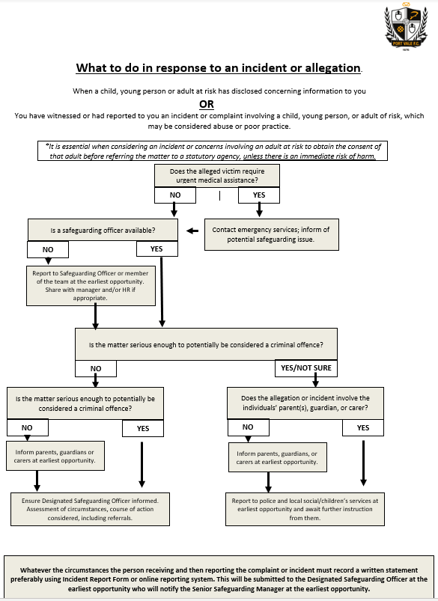

Appendix D – PORT VALE FOOTBALL CLUB SAFEGUARDING NETWORK

Authority from Port Vale Board and acceptance of Policy:

Signed by:

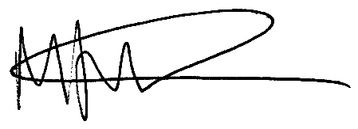

Matt Hancock (Board Member) Date: 01/08/2025

SSM Date:

This policy will be reviewed by the Designated Safeguarding Officer annually and also on a regular basis, in particular following learning outcomes as a result of a significant incident or when legislation or statutory guidance changes are implemented.

