





SAFEGUARDING CRISIS
MANAGEMENT PLAN
2025-26

Version Control
Document Title: | Safeguarding Crisis Management Plan – 2025-26
Document Owner: | Port Vale Football Club – Gary Cliffe – Head of Safeguarding
Reference: | July 2025 (Revised Version)

Document Review
Last Reviewed | Position
07/2022 | Tim Bailey
08/2023 | Rich Talbot
29/07/2024 | Rich Talbot
31/07/25 | G Cliffe

Version History
Version | Date Released | Originator | Authorised | Comments
1.0 | 07/2022 | Tim Bailey | Board | New Plan
1.1 | 08/2023 | Rich Talbot | Board | Revised Version
1.2 | 29/07/2024 | Rich Talbot | Board | Revised Version
1.3 | 31/07/2025 | G Cliffe | Board | Annual Review

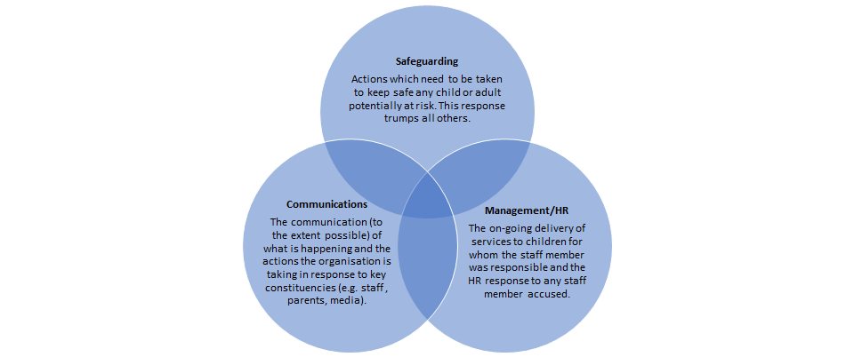
Safeguarding crises are complex and involve three different types of response. This document is intended to guide the senior management team at times of crises, particularly any safeguarding crises. A senior member of staff will complete the checklists alongside other relevant staff members so that an action plan can be decided. Best practice would expect this document to be completed within 2 hours of the incident being reported.

The most effective management of a safeguarding crisis involves coordination of all three headings.

Whilst the safeguarding response must always come first, simultaneous attention to the other areas of response will create a strong sense of direction and coordination, providing the greatest reassurance to stakeholders (the ‘sweet spot’).

This requires safeguarding leads working in close coordination with the senior leadership team, board, Human Resources, legal advisors and internal and external communications teams.

Crisis Checklist - Safeguarding

Are any urgent actions needed to safeguard a child or children in an emergency? If so, call LADO, Police or other emergency services 999.
Are there other children who may be at immediate risk in addition to the child or children in the allegation? If so, notify LADO/Police.
Which agencies need to be informed immediately (e.g., LADO, Police, Children’s Services)?
Does any other body need to be informed (e.g., Charity Commission or other regulatory body)?
What are your immediate next steps? Take telephone advice from LADO/Police/Children’s Services and agree your actions.
Will Police be coming on site (e.g., to arrest or conduct a search)? Discuss with LADO and Police the best approach so as not to cause unnecessary anxiety to other children or parents.
Who do you need to speak to in order to implement the agreed actions? Speak to them and implement actions.
What do you need to say to the child, his/her parents and the staff member concerned now? Agree this with the LADO, Police or Children’s Services as appropriate.
Has LADO convened a strategy meeting? If so, decide who attends and what you want to achieve.
Work with the authorities not against them. But remember the organisation has priorities too, so identify them in advance and be sure to include them in any discussions around future strategy.

Crisis Checklist - Management/HR

Who in the organisation (Including CEO) needs to be made aware immediately? Inform them
Where is the staff member now? Is he/she in contact with children and if not when will the next opportunity for contact be? Agree with LADO and/or Police your next steps. Do not inform or suspend the staff member before reaching that agreement – you could be tipping off.
Whilst Police investigations are underway, how do you ensure the staff member’s duties are carried out in the coming days and how do you explain his/her absence?
Does any other body need to be informed (e.g., Charity Commission or other regulatory body)? Does the EFL, FA, DBS need to be informed?
What information is known about the staff member? Ensure you locate and provide all information to LADO or Police (probably at strategy meeting).
How long will Police investigation and potential criminal prosecution take? If there is already clear evidence of misconduct, consider dismissal
Has the crisis shown up any immediate staff training issues (e.g., reporting of allegations or concerns)? If so, organise ASAP.
Do you need to bring in any additional external resource to assist?
If Police/LADO do not pursue the matter themselves conduct your own investigation and risk assessment.
Where dismissal of staff member results (or resignation pending outcome of investigation) notify DBS/NCTL or other relevant agencies as appropriate. Never use compromise agreements, agreed resignations, or agreed references.

Crisis Checklist - Communications

Don’t wait for a crisis to happen before you act. Develop a safeguarding risk register and crisis management plan. Agree the constituents and roles of your crisis response team, including specialist legal and communications advisors and spokesperson. | See appendix 1
Time is of the essence. Agree who is authorised to make final decisions quickly.
Ensure coordination between your legal and communication strategies and get advice early in the process
What factors govern or limit communications? Check your safeguarding policies and consider any statutory rules about anonymity. Take advice from the LADO, Police and Children’s Social Care services.
Don’t be in denial – establish the facts and consider the broader context. Are there other issues which can be conflated to suggest a pattern of behaviour?
Be honest and transparent. Do not risk being accused of a cover-up or brushing things under the carpet as this will undermine trust.
Get the tone right by putting yourself in the shoes of the receiving audience. Explain the actions you are taking and demonstrate care and concern for those affected. Have a plan to ensure it will not happen again.
Consider the needs of all your stakeholder audiences and pre-empt their questions by providing them with sufficient information. Provide appropriate lines of communications for them and be responsive.
Don’t procrastinate. Demonstrating that you are managing the situation well will help retain trust. Stakeholders prefer to hear about issues from you rather than from the media.
Don’t say anything that you aren’t prepared to see in print or online.

Crisis Response Team

Matt Hancock, Chief Executive Officer (CEO)
Lead decision maker, communications with EFL and knowledge of regulations
matt.hancock@port-vale.co.uk
07841 669182
Ensure completion of checklist

Gary Cliffe, Head of Safeguarding
Safeguarding advice and referral to appropriate authorities
gary.cliffe@port-vale.co.uk
07703 753688

Michelle Fallows, Head of People
Employment guidance
michelle.fallows@port-vale.co.uk
07990 032779

Marian Humphreys, Solicitor
Legal guidance
marian.humphreys@port-vale.co.uk

Luke Cassidy, IT Support Engineer
Guidance and actions based on any IT breach
luke.cassidy@port-vale.co.uk
07782 965102

Will Ryder, Head of Academy
Key liaison for any Academy crisis
will.ryder@port.vale.co.uk
07555 284391

Dan Townley, Media & Content Manager
Lead on media crisis checklist
Contact with the media
dan.townley@port-vale.co.uk
07391 626325

Crisis Response Team (Continued.)

Will Turner, Head of Community
Contact for all Foundation matters including Bescura
will.turner@port-vale.co.uk
07585 652193

EXTERNAL CONTACTS

EFL Safeguarding Contacts
Alex Richards – 07792 284740 arichards@efl.com
Scott Flynn - 07583 074386

Stoke on Trent Safeguarding Children Partnership
01782 235100 (08:30 – 18:00 Hours)
01782 234234 (Out of Hours)

Staffordshire Children Advice & Support Service
0300 111 8007 (08:30 – 17:00 Hours)
0345 604 2886 (Out of Hours)

Stoke-on-Trent City Council Adult Safeguarding Services 0800 561 0015 (24 Hours)

Staffordshire Adult Safeguarding Services
0345 604 2719 (08:30 – 17:00 Hours)
0345 604 2886 (Out of Hours)

Stoke on Trent LADO – 0800 561 0015

Staffordshire LADO – 0300 111 8007

Staffordshire FA: 01785 256994
Email: support@staffordshirefa.com

Staffordshire FA Safeguarding: Jan Scott 01785 256994 Ext.205 mob: 07969 294023

Police 999 (Emergency) 111 (Non-emergency)

Childline 0800 1111

Authority from Port Vale Board and Acceptance of Plan

Senior Safeguarding Manager  (Board Member): | Claire Halket
Signature: | Claire Halket
Date: | 29/07/2024 (Annual Review)

Chief Executive Officer  (Board Member): | Matt Hancock
Signature: | 
Date: | 01/08/2025 (Annual Review)

This Plan will be reviewed by the Head of Safeguarding regularly and annually or following learning
outcomes as a result of a significant incident or when legislation or statutory guidance changes are implemented.

