





CHILDREN ATTENDING FOOTBALL MATCH
POLICY & PROCEDURES
2025-26

For the latest copy refer to the Club Website

Version
Document Title: | Children attending Football Match Policy 2024/2025
Document Owner: | Port Vale Football Club – Gary Cliffe – Head of Safeguarding
Reference: | July 2025 (Revised Version)

Document Review
Last Reviewed | Position | Reason
21/02/2023 | Rich Talbot (DSO) | Review to include “Lost Child Meeting Point” / What is a “Responsible Adult”
03/08/2023 | Rich Talbot (Safeguarding Manager) | Update to include minimum age to attend fixtures alone increased to 14 years
02/02/2024 | Rich Talbot (Head of Safeguarding) | Updated staff changes & structure
04/07/2024 | Rich Talbot (Head of Safeguarding) | Annual Review
31/07/2025 | Gary Cliffe (Head of Safeguarding) | Annual Review

Version History
Version | Date Released | Originator | Authorised | Comments
1.0 | 03/2021 | Tim Bailey | Board | New Policy
1.1 | 08/2021 | Tim Bailey | Board | Revised Version
1.2 | 08/2022 | Tim Bailey | Board | Revised Version
1.3 | 21/02/2023 | Rich Talbot | Board | Revised Version
1.4 | 03/08/2023 | Rich Talbot | Board | Revised Version
1.5 | 02/02/2024 | Rich Talbot | Board | Revised Version
1.6 | 04/07/2024 | Rich Talbot | Board | Revised Version
1.7 | 31/07/2025 | G Cliffe | Board | Revised Version

1. Introduction
Statement
1.1 Port Vale Football Club (hereafter referred to as the Club) is committed to ensuring that we create a safe environment for everyone visiting or taking part in activities at the Club. The Club takes our responsibility to safeguard and promote the welfare of all children and young people very seriously. Our approach to any concerns will always be children and young people focused and their best interests will always be paramount when dealing with any incident. This policy sets out our commitment to safeguarding and provides a framework for what to do if concerns arise about the welfare or protection of children and young people whilst at the Club, or those who become known to the Club.
Carol Shanahan (Chair and Co-owner)
Scope
1.2 This policy is for use across the Club and is to be observed by all those working or volunteering and who may encounter children and young people, this to ensure best practice in safeguarding is promoted and adhered to.
Activities undertaken at the following departments/locations are under the remit of this policy including:
Port Vale Football Club and the Vale Park Stadium
Port Vale First Team
Port Vale Academy
Port Vale Foundation Trust and Youth Development
Port Vale Women’s Team
Port Vale Retail Store
Any location visited by staff/volunteers in an official capacity.
The Club acknowledges and accepts it has a statutory obligation and responsibility for the wellbeing and safety of all children and young people who are under the care of the Club, are utilising the facilities or become known to the Club. Every person working or volunteering at the Club has a “Duty of Care” to safeguard the welfare of children and young people by creating an environment that protects them from harm.
The wellbeing of children and young people is paramount, all staff must make themselves aware of the Club’s Safeguarding Children and Young People Policy.
1.3 Port Vale Football Club endeavours to ensure that attending a football match is a positive experience for everyone. When considering whether to bring your child to a match please consider their age, time of the match, including both start and finish times, weather conditions, crowds and any other applicable risks.

2. Stadium Age Restrictions
2.1 When attending a football fixture at the Vale Park Stadium, the Club have several rules relating to any child or young person visiting same:
- A child is anyone that is under the age of 18 years (they have not yet reached their 18th Birthday).
- A child or young person attending a match must have a valid ticket regardless of age.
- Anyone under the age of 12 years is eligible for ticket concessions through our Team
Valiant club but must be accompanied by a responsible adult. (Anyone accompanying someone under the age of 12 years must be over 18 years)
- A child or young person aged between 12 and 17 years are eligible for junior concessions.
- Anyone under the age of 14 years (13 years and below) must be accompanied by a parent or other responsible adult, an adult is anyone aged 18 years or older.
- Any child aged under 2 years should sit on the lap of their parent or other responsible adult, those aged 2 years or over should have their own allocated seat within the Stadium.
- Please refer to Matchday Safeguarding Code of Conduct (See Appendix B below).
*Please note: these rules may be amended where a third party uses the stadium for non-football events. All current ticketing prices are contained on the Port Vale Club website via this link https://www.port-vale.co.uk
Searches
2.2 Being searched is a condition of entry into the Stadium in accordance with the English Football League (hereafter referred as EFL) Ground Regulations - further information here.
If a child or young person, along with their responsible adult, do not consent to the search, entry may be refused regardless of whether they have purchased a ticket.
The circumstances in which a Steward may carry out a search can depend upon the risks around the match, intelligence from the Police and the previous history of the fixture involved. If no responsible adult is present the search will be conducted sensitively in the presence of a Dedicated Matchday Safeguarding Team member who are present at fixtures at the Club (*such staff are easily identifiable by their bright pink coloured bibs*).

3. Weather Conditions
3.1 Throughout the football season weather conditions change considerably and visitors are likely to experience all weather types.
- Early and late season may mean high temperatures and strong sunshine – parts of the stadium may be in full sun for long periods of time.
- Mid-winter matches, especially at night, may mean sub-zero temperatures, rain, wind and snow. Frost and ice underfoot may also be an extra hazard for those carrying or walking with small children so be very careful in cold, wet, or windy conditions. Babies and small children can become cold very quickly, even at times of the year where adults feel that it is warm outside. They will more than likely be inactive at the stadium and get cold quickly so keep an eye on your child – Don’t forget – unusually quiet with bright red skin doesn’t necessarily mean they are warm and happy; this could be a sign of hypothermia (their skin will be cold). If you do choose to bring your child to a match, remember to dress them in appropriate layers.
3.2 We want you and your child to enjoy your visit. If you are bringing a child to the stadium, think about their needs first, if you cannot guarantee their comfort or safety then please consider other childcare options so that you can still attend and enjoy the game if possible.

4. Noise including Racist Language
4.1 Football matches are noisy events, the noise levels can go up and down throughout the game. Small children are more sensitive to noise and thus are more prone to hearing damage. Whilst long term damage from the noise at football grounds is unlikely, the peak sounds can reach the same levels experienced in a nightclub. Ear plugs or muffs may help to protect the childs hearing and may also help to keep them a little bit warmer on cold days or evenings.
4.2 Some children may also find the cheering, singing and chanting in some parts of the stadium a little frightening and unfortunately there may also be some spectators occasionally using language that is inappropriate for young people to hear.
4.3 It makes no difference who hears this type of language, if the person perceives it to be of a racist or offensive nature then it is. This is a criminal offence and should be reported to a Safety Steward at the soonest opportunity.
4.4 The ‘Kick it Out’ movement is available for reporting, and this can be done by going to the website via this link https://www.kickitout.org.
4.5 The Club also operates a ‘Match Day Abuse Hotline’ that is managed by Control Room staff before, during and at the conclusion of a match. Details are as follows: Port Vale Football Club Abuse Hotline (Match Day Only) (T): 07801 216675. Supporters are encouraged to report any incidents of a homophobic or racist nature including, if possible, a description of the perpetrator, stand, seat number and nature of the abuse witnessed.

5. Stay Alert
5.1 Footballs are hard, being struck by a ball can hurt and even cause injury. In many areas of spectator seating there is a risk of being struck by a ball from the pitch. This risk is escalated behind the goals particularly during team warm-ups when there are multiple balls on the pitch that may come from any angle. Please ensure that you and your child stay alert to the possibility of this.

6. What to do if you have a concern at a Fixture
6.1 During a fixture please do not hesitate to report a concern to one of our Safety Stewards who will notify a member of the Dedicated Matchday Safeguarding Team. If you have a concern about a child or young person you may also contact the Head of Safeguarding at the Club on safeguarding@port-vale.co.uk at any time (See Appendix A below).

7. Lost Child Meeting Point
7.1 The Club have a number of “Lost Child Meeting” points clearly signed and situated within each stand of the stadium. Please familiarise yourself with these points clearly and have a plan to meet there if you get separated. Please ensure your Child is aware of this location (See Appendix C below).

8. Associated Policies
Other associated policies linked directly or indirectly to this Policy include:
- Safeguarding Children & Young People Policy & Procedures 2024-25
- Child Friendly Safeguarding Children Policy & Procedures 2024-25
- Allegation of Abuse against Staff Policy & Procedures 2024-25

Staff at Port Vale FC are trained and experienced in providing a safe environment for all our visitors but where there are large gatherings of people there are risks. As a result, we have developed a Safeguarding Code of Conduct which is attached at Appendix B.

Appendix A – INTERNAL CONTACT DETAILS

List of Internal Contacts

Senior Safeguarding Manager (SSM)(Board Representative)

Matt Hancock (CEO)

(E): matt.hancock@port-vale.co.uk / (M): 01782 655800

Head of Safeguarding & Lead Disclosure Officer

Gary Cliffe

(E): gary.cliffe@port-vale.co.uk / (M): 07703 753688

Safeguarding Team

Concerns / General Enquiries

(E): safeguarding@port-vale.co.uk / (T): 01782 655830

Port Vale Football Club Abuse Hotline (Match Day Only)
Match Day Control Room
Reporting of Homophobic / Racial Abuse
(T): 07801 216675
Disability Access Officer (DAO)
Dave Richards
(E): DAO@port-vale.co.uk / (M): 01782 655821

Appendix B – MATCH DAY SAFEGUARDING CODE OF CONDUCT
Port Vale Football Club - Match Day Safeguarding Code of Conduct 2024-2025

- Anyone under the age of 14 years (13 years and below) must be accompanied by a Parent or other Responsible Adult, an adult is anyone aged 18 years or older.

- The role of the Parent/Responsible Adult is to safeguard the interests, rights and welfare of the Child whilst present on the Stadium footprint.

- Any Child under the age of 10 years (9 years and below) should always be kept at arm’s length and clearly in view. Should the Child need to leave your presence, always be aware of their location during your visit.

- If you fail to supervise your Child, you may be asked to leave the Stadium along with your Child.

- Please familiarise yourself with the “Lost Child Meeting Point” clearly signed within each section of the Stadium and have a plan to meet there if you get separated. Ensure your Child is aware of this location.

- Should you get separated from your Child please contact a Safety Steward immediately and listen to announcements over the stadium speakers.

- On a match day a number of Dedicated Safeguarding Stewards will be available to help. They are identifiable by their pink-coloured high visibility vests.

- Other Safety Stewards are situated around the stadium in high visibility clothing for your safety and confidence.

- Our Safety Stewards are trained in how to deal with a lost Child, please ensure your Child knows not to go off with any person that they do not know.

- In an emergency, please ensure your Child is aware of what to do including how to evacuate the stadium and where to meet up with you.

- Should you see anything that causes you a concern or does not look right please report this to a Safety Steward.

- Ensure that your Child knows who to contact should they become lost or worried.

Remember if something doesn’t look or feel right, it probably isn’t………Report it!
Appendix C – Lost Child Meeting Point / Stadium Plan

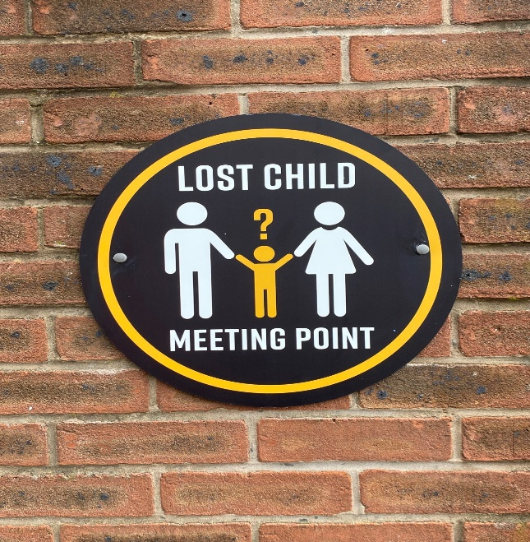

LOCATIONS OF LOST CHILD MEETING POINTS

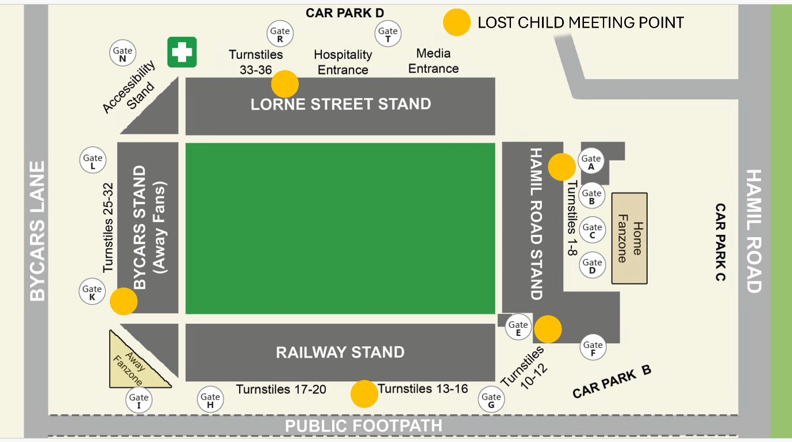

Authority from Port Vale Board and Acceptance of Policy
Senior Safeguarding Manager  (Board Member): | Claire Halket
Signature: | Claire Halket
Date: | 04/07/2024 (Annual Review)

Chief Executive Officer  (Board Member): | Matt Hancock
Signature: | 
Date: | 01/08/2025 (Annual Review)

This policy will be reviewed by the Head of Safeguarding regularly and annually or following learning outcomes as a result of a significant incident or when legislation or statutory guidance changes are implemented.

